**Arun M**

**23122110**

**3MScDS B**

**Machine Learning Lab 02**

**Teachable Machine**

**Objective :- To Make ML Model to detect ID Cards Photo of Different persons.**

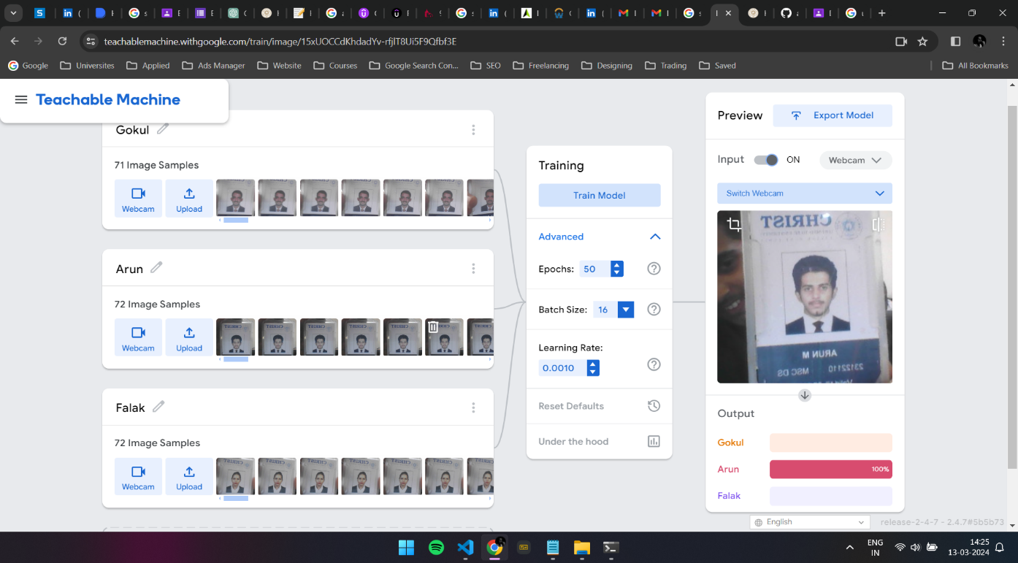

**Link :-** <https://teachablemachine.withgoogle.com/models/v5cfj77rm/>